# Deep Learning Basic Concepts

# 1: What is Deep Learning?

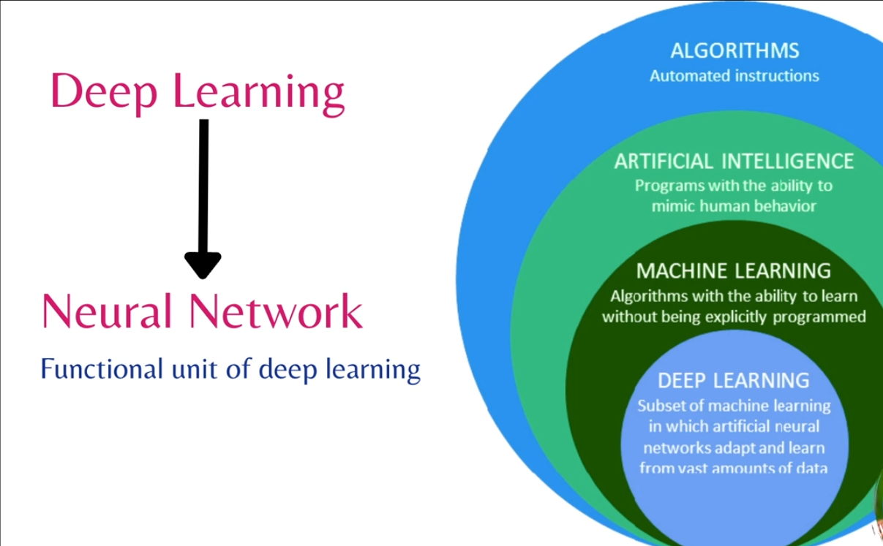Deep Learning (DL) is a **subset of Machine Learning (ML)** that uses **artificial neural networks** to model complex patterns in data. It's particularly powerful for tasks like **image recognition, natural language processing, and speech recognition**.

# 2: How Does Deep Learning Work?

Deep Learning is based on **Artificial Neural Networks (ANNs)**, which are inspired by the structure of the human brain. The key components are:

* **Neurons (Nodes):** The basic units of computation, like biological neurons.  
  **Layers:**
* **Input Layer:** Receives raw data (e.g., pixels from an image).
* **Hidden Layers:** Perform transformations using mathematical operations. More hidden layers = "deep" networks.
* **Output Layer:** Produces the final prediction or classification.
* **Weights & Biases:** Control how signals are transmitted between neurons.  
  **Activation Functions:** Introduce non-linearity (e.g., ReLU, Sigmoid, Tanh).  
  **Backpropagation & Optimization:** The model learns by **adjusting weights** using algorithms like **Gradient Descent**.

# 3: Key Deep Learning Architectures

Different neural network architectures are used for different problems:

* **Feedforward Neural Networks (FNN):** Basic fully connected networks.
* **Convolutional Neural Networks (CNN):** Used for **image processing** (e.g., object detection, face recognition).
* **Recurrent Neural Networks (RNN):** Used for **sequential data** (e.g., speech, text, time series).
* **Long Short-Term Memory (LSTM):** An improved RNN for long-term dependencies.
* **Transformers:** Used for **NLP**, like **ChatGPT**! (e.g., BERT, GPT, T5).
* **Generative Adversarial Networks (GANs):** Used for **image synthesis, style transfer, and deepfake creation**.

# What is a Neural Network?

A **Neural Network (NN)** is a computational model designed to **mimic** the way the human brain processes information. Just like our brain consists of billions of interconnected neurons, an **Artificial Neural Network (ANN)** consists of interconnected **artificial neurons** that process data and make decisions.

Neural networks are the backbone of **Deep Learning**, and they are widely used in **image recognition, speech processing, autonomous driving, medical diagnosis, and more**.

**Artificial Neuron (Perceptron) → Inspired by Biological Neurons**

* The **basic unit** of an ANN is the **Neuron**/**Perceptron**.
* It **receives inputs, applies weights, sums them up, and passes through an activation function**.

🔹 **Mathematical Model of a Neuron:**

Where:

* = Input features
* = Weights (synaptic strength)
* **=** Bias (threshold to shift the function)
* = Activation function (e.g., ReLU, Sigmoid)
* = Output

**Parallel to the Brain:**

* Just like a **biological neuron** processes input signals and fires an output, an **artificial neuron** processes numerical inputs and produces an output.

**Forward Propagation → Inspired by Signal Flow in the Brain**

* In the **brain**, signals travel **from dendrites → neuron → axon → synapse → next neuron**.
* In **ANNs**, **Forward Propagation** is the process where:
  1. Input is passed through **each layer** (Input → Hidden → Output).
  2. Each neuron applies weights and activation functions.
  3. The final output is generated.

**Backpropagation & Gradient Descent → Inspired by Learning & Memory**

* The **human brain learns** by adjusting **synaptic connections** over time (**neuroplasticity**).
* **ANNs learn** by adjusting **weights** using **backpropagation and gradient descent**.

**Backpropagation Algorithm (How Neural Networks Learn):**

* Compute error between **predicted output** & **actual output** (**Loss Function**).
* Use **Gradient Descent** to adjust weights.
* Repeat the process until error is minimized.

# Neural Network vs. Human Brain: Basic Components

|  |  |  |  |  |  |  |  |  |  |  |  |  |  |  |  |  |
| --- | --- | --- | --- | --- | --- | --- | --- | --- | --- | --- | --- | --- | --- | --- | --- | --- |
| | **Human Brain** | **Artificial Neural Network** | | --- | --- | | **Neuron** – A biological cell that processes and transmits information. | **Artificial Neuron (Perceptron)** – A mathematical function that processes input and generates an output. | | **Dendrites** – Receive input signals from other neurons. | **Input Layer** – Receives raw data (e.g., pixels from an image, words from a sentence). | | **Axon** – Transmits electrical signals to other neurons. | **Connections (Weights & Biases)** – Control how signals are passed between neurons. | | **Synapses** – Junctions between neurons where signals are transmitted. | **Weights (Synaptic Strength)** – Determines how much influence one neuron has on another. | | **Neurotransmitters** – Chemical messengers that influence signal transmission. | **Activation Function** – Introduces non-linearity (e.g., Sigmoid, ReLU, Tanh). | | **Brain Cortex (Layers of Neurons)** – Responsible for complex processing. | **Hidden Layers** – Perform transformations and feature extraction. | | **Learning & Memory** – Adjusts connections (synaptic plasticity) to improve responses over time. | **Backpropagation & Gradient Descent** – Adjusts weights to minimize error and improve learning. | |

# Popular Deep Learning Frameworks

These frameworks make building deep learning models easier:

**TensorFlow:** Developed by Google, great for large-scale applications.  
**PyTorch**: Developed by Facebook, widely used in research & industry.  
**Keras**: High-level API that simplifies TensorFlow.

# Applications of Deep Learning

DL is behind many cutting-edge technologies:

* Computer Vision (Face Recognition, Object Detection)
* Natural Language Processing (Chatbots, Translation, Sentiment Analysis)
* Autonomous Vehicles (Self-driving Cars)
* Medical Imaging (Detecting Tumors, Diagnosing Diseases)
* Finance (Fraud Detection, Stock Price Prediction)

**Why is Deep Learning So Powerful?**

* **Handles Large Data** – Can process huge amounts of data efficiently.
* **Feature Learning** – Learns features automatically, unlike traditional ML.  
  **High Accuracy** – Outperforms traditional models in complex tasks.
* Deep Learning has revolutionized AI, and it's only getting **better and faster** with **improved hardware (GPUs, TPUs)** and **larger datasets**.

# Types of Artificial Neural Networks (ANNs) – Basic & Advanced

Artificial Neural Networks (ANNs) come in different architectures, each designed for specific tasks. They can be broadly categorized into **basic and advanced types**.

**1. Basic Types of Artificial Neural Networks (ANNs)**

1. **Feedforward Neural Network (FNN)**

The simplest type of ANN where information moves only in one direction—**from input to output, without loops**.

* Structure: Consists of an **Input Layer, Hidden Layers, and Output Layer**.
* Uses **Forward Propagation** for computation.

Use Cases: Image classification, Handwritten digit recognition (e.g., MNIST dataset).

1. **Single-Layer Perceptron (SLP)**

The simplest neural network with only one layer of neurons.

* Structure: One input layer and one output layer (**no hidden layers**).
* Uses a **step activation function** to classify linearly separable data.

Limitations: Cannot solve non-linearly separable problems (e.g., XOR problem).

Use Cases: Simple binary classification problems.

1. **Multi-Layer Perceptron (MLP)**

An improved version of the Single-Layer Perceptron with multiple hidden layers, allowing it to model complex data.

* Structure: Multiple layers of neurons (**Input → Hidden → Output**).
* Uses **activation functions** like ReLU, Sigmoid, Tanh.
* Trained using **Backpropagation and Gradient Descent**.

Use Cases: regression, classification, Speech recognition, Image recognition, Predictive analytics.

1. **Radial Basis Function Neural Network (RBFNN)**

Uses **Radial Basis Functions** as activation functions, which respond to specific regions of input space.

* Structure: Three layers – Input, Hidden (RBF layer), and Output.
* Each hidden neuron computes the **distance** between the input and its center.

Use Cases: Function approximation, Control systems.

1. **Recurrent Neural Network (RNN)**

Unlike FNNs, RNNs have **memory** and can process sequential data by maintaining information from previous inputs.

* Structure: Loops exist in hidden layers (**feedback connections**).
* Uses **time-step-based processing**.

Challenges: Vanishing gradient problem (solved using LSTMs & GRUs).

Use Cases: Time-series prediction, Speech recognition, Language modeling.

**2. Advanced Types of Artificial Neural Networks (ANNs)**

1. **Convolutional Neural Network (CNN)**

Designed specifically for **image and video processing**, CNNs extract features from images through convolutional layers.

* Structure: Convolutional Layers, Pooling Layers, Fully Connected Layers.
* Reduces dimensionality using **Max Pooling or Average Pooling**.

Use Cases: Image recognition, Object detection, Video analysis.

1. **Long Short-Term Memory (LSTM) – A Type of RNN**

An advanced RNN that solves the **vanishing gradient problem** by introducing gates (**Forget, Input, and Output gates**) to retain long-term dependencies.

Use Cases: Speech-to-text conversion, Sentiment analysis, Language translation.

1. **Gated Recurrent Unit (GRU) – A Variant of LSTM**

A simplified version of LSTMs that retains important features while reducing computational complexity.

Use Cases: Similar to LSTM but faster and more efficient.

1. **Autoencoder (AE)**

A self-learning network that reduces dimensionality by compressing and reconstructing input data.

* Structure: **Encoder** (compresses input) → **Bottleneck Layer** → **Decoder** (reconstructs input).

Use Cases: Anomaly detection, Image denoising, Data compression.

1. **Variational Autoencoder (VAE)**

An improved version of Autoencoders that generates new data points similar to the input.

Use Cases: Synthetic image generation, Data augmentation.

1. **Transformer Networks (e.g., BERT, GPT)**

Uses an **Attention Mechanism** to process entire sequences in parallel, solving limitations of RNNs.

Use Cases: Machine translation, Chatbots, Text summarization.

1. **Generative Adversarial Network (GAN)**

Consists of two competing networks—**Generator** (creates fake data) and **Discriminator** (detects fake data).

Use Cases: Deepfake generation, Super-resolution images, AI art.

1. **Self-Organizing Map (SOM)**

A type of **unsupervised neural network** used for clustering and visualization.

Use Cases: Feature extraction, Pattern recognition.

1. **Extreme Learning Machine (ELM)**

A fast alternative to traditional neural networks that randomly sets hidden layer parameters and only trains output weights.

Use Cases: Real-time learning applications.

1. **Capsule Networks (CapsNet)**

An advanced version of CNNs that retains spatial hierarchies between objects.

Use Cases: 3D object recognition, Medical imaging.

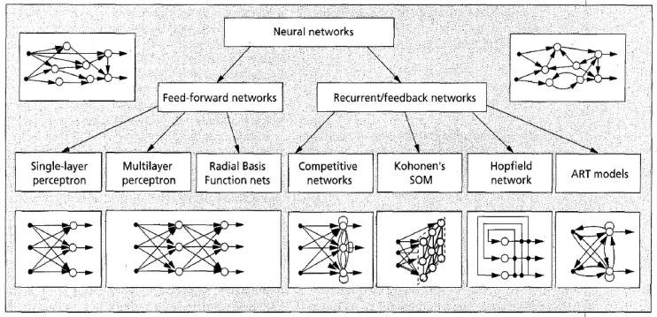

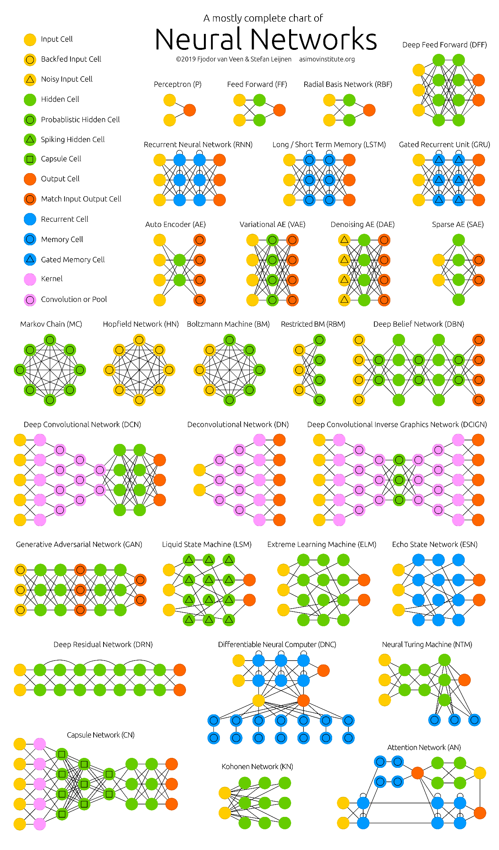

# What is Forward and back propagation?

* **Forward Propagation**

Forward propagation is the process in which input data passes through the neural network layer by layer to generate an output. Each neuron takes inputs, applies weights and biases, and passes the result through an activation function to introduce non-linearity. This process continues from the input layer through hidden layers to the output layer, producing a predicted value. The network does not learn anything in this step; it simply computes the output based on the current weights.

* **Backpropagation**

Backpropagation is the learning mechanism that adjusts the network’s weights to minimize prediction errors. It starts by calculating the **loss** (difference between predicted and actual output) using a loss function. Then, it computes how much each weight contributed to the error using the **chain rule of calculus** (gradient computation). Using **gradient descent**, the algorithm updates weights in the opposite direction of the error to reduce the loss. This process repeats iteratively, improving the network’s accuracy over time.

# Activation function, types and its uses?

* **What is an Activation Function?**

An activation function is a mathematical function that determines whether a neuron should be activated by applying a transformation to the input. It introduces non-linearity, allowing neural networks to learn complex patterns. Without activation functions, neural networks would behave like simple linear models, limiting their ability to handle tasks like image recognition or language processing.

* **How Does It Work?**

Each neuron receives weighted inputs, sums them, and adds a bias term. This sum is passed through an activation function, which transforms the output before passing it to the next layer. During backpropagation, activation functions affect gradient flow, influencing the network’s learning process.

* **Types and Their Uses:**

**Sigmoid:** Outputs values between 0 and 1, useful for **binary classification**, but suffers from vanishing gradients.

**Tanh:** Outputs between -1 and 1, making it better than sigmoid for **sequential data** but still has gradient issues.

**ReLU:** Outputs positive values as they are and sets negatives to zero. It is the most common activation in **deep networks** like CNNs but can cause dying neurons.

**Leaky ReLU:** Allows small negative values, fixing the dying ReLU issue, and is used in **CNNs and deep architectures**.

**Softmax:** Converts outputs into probability distributions, making it ideal for **multi-class classification**.

**Swish & ELU:** Advanced functions used in **deep learning architectures** to improve learning efficiency and speed.

* **Choosing the Right Function:**

For **binary classification**, sigmoid is preferred, while softmax is ideal for **multi-class classification**. ReLU and its variants are best for **deep learning models**, while tanh is commonly used in **recurrent networks** like RNNs and LSTMs. Swish and ELU are used in more **advanced models** for better learning efficiency.

Types of NN based on no of hidden layers of NN

# Applications of neural Network

Neural networks (NNs) have a wide range of applications across industries, thanks to their ability to model complex patterns and relationships in data. Here’s a rundown of key applications, categorized by the type of NN and problem they address:

**1. Single-Layer Perceptron (No Hidden Layers)**

* Binary classification tasks (e.g., spam vs. not spam for simple datasets).
* Basic decision-making systems (e.g., credit approval based on linear rules).
* **Use Case Example:** Early pattern recognition systems, like classifying handwritten digits (if linearly separable).

**2. Shallow Neural Networks (One Hidden Layer)**

* Simple regression problems (e.g., predicting house prices based on basic features).
* Pattern recognition (e.g., identifying shapes or characters).
* Control systems (e.g., adjusting parameters in industrial processes).
* **Use Case Example:** Optical character recognition (OCR) for typed text in early systems.

**3. Deep Neural Networks (Multiple Hidden Layers)**

Deep NNs power most modern AI breakthroughs. Their applications depend on specialized architectures:

**a. Convolutional Neural Networks (CNNs)**

* **Image Recognition:** Classifying objects in photos (e.g., cats vs. dogs).
* **Facial Recognition:** Identifying people in security systems or social media.
* **Medical Imaging:** Detecting tumors in X-rays or MRIs.
* **Autonomous Vehicles:** Recognizing road signs, pedestrians, and obstacles.
* **Use Case Example:** Google’s DeepMind diagnosing eye diseases from retinal scans.

**b. Recurrent Neural Networks (RNNs) & LSTMs**

* **Time Series Prediction:** Forecasting stock prices or weather.
* **Speech Recognition:** Converting audio to text (e.g., Siri, Alexa).
* **Natural Language Processing (NLP):** Sentiment analysis, chatbots.
* **Music Generation:** Composing melodies based on patterns.
* **Use Case Example:** Predictive text in smartphone keyboards.

**c. Transformers (Advanced Deep NNs)**

* **Machine Translation:** Translating languages (e.g., Google Translate).
* **Text Generation:** Writing articles, stories, or code (e.g., ChatGPT, Grok).
* **Summarization:** Condensing long documents into key points.
* **Question Answering:** Powering virtual assistants or search engines.
* **Use Case Example:** BERT improving search result relevance on Google.

**d. Generative Adversarial Networks (GANs)**

* **Image Generation:** Creating realistic faces or artwork (e.g., DeepFakes).
* **Data Augmentation:** Generating synthetic data for training other models.
* **Video Game Design:** Procedurally generating textures or environments.
* **Use Case Example:** NVIDIA’s AI generating photorealistic human faces.

**e. General Deep Learning Applications**

* **Recommendation Systems:** Suggesting movies (Netflix) or products (Amazon).
* **Fraud Detection:** Identifying unusual patterns in financial transactions.
* **Robotics:** Enabling robots to navigate and manipulate objects.
* **Drug Discovery:** Predicting molecular interactions for new medicines.